Project 2 (v1.0)

Due: 5 April 2015, Sun 23:59 hrs.

Reminder:

We view honesty very seriously. According to the course outline: “each group is expected to produce solutions on your own. You should not consult or discuss about the assigned problems with other groups and definitely not refer to other’s work. Violation of this policy will be deemed as cheating”.

Instructions:
- There are 3 questions in this exercise to be completed in your assigned teams of two. Refer to eLearn for your new teams.
- You need to submit a PDF file for Q3 at the eLearn Dropbox. You need to submit code for all 3 questions at the Submission Server.
- You are required to edit p2q1.rb, p2q2.rb and p2q3.rb that are given to you. Zip them up as <any_name>.zip and submit the zip file to the Submission Server. Refer to the “news” item at the Submission Server as to when you can start submitting solutions.
- You can submit your solutions to the Submission Server as many times as you wish, but the final submission on the deadline will be taken as your final submission.

Q1 [10 marks] Gunpowder Fire Simulation

Consider a flat world on a two dimensional plane. Let the plane be N by N, and each integer coordinate represents a cell. Some of these cells contain gunpowder; the rest of them are empty. We use a two-dimensional array to represent this plane, where “0” represents an empty cell and “1” represents a cell with gunpowder.

In this world, lightning strikes are commonplace. If lightning strikes on a cell with gunpowder, the gunpowder will catch fire and the fire will spread to all direct neighbor cells with gunpowder (the direct neighbor of a cell is to its north, south, east, and west – the cells to the north-east, north-west, south-east and south-west are not considered direct neighbors). Empty cells act as fire breaks, preventing the fire from spreading. After the fire, cells with gunpowder that had caught fire should be marked “0” as the gunpowder gets burnt, and it becomes an empty cell.

Figure 1(a) shows an example of a 6x6 plane. Figure 1(b) shows the aftermath of a lightning strike at (y=3, x=2).

Figure 1(a). Original 6x6 plane | Figure 1(b). Same plane after a lightning strike  at cell (y=3, x=2)
   |  | x
   |  | 0 | 1 | 2 | 3 | 4 | 5
  y | 0 | 1 | 0 | 1 | 1 | 1 | 1
  y | 1 | 1 | 0 | 1 | 1 | 0 | 1
  y | 2 | 1 | 0 | 1 | 0 | 0 | 0
  y | 3 | 0 | 0 | 1 | 0 | 0 | 0
  y | 4 | 0 | 1 | 0 | 0 | 1 | 1
  y | 5 | 0 | 1 | 1 | 1 | 1 | 1
   |  | x
   |  | 0 | 1 | 2 | 3 | 4 | 5
  y | 0 | 1 | 0 | 0 | 0 | 0 | 0
  y | 1 | 1 | 0 | 0 | 0 | 0 | 0
  y | 2 | 1 | 0 | 0 | 0 | 0 | 0
  y | 3 | 0 | 0 | 0 | 0 | 0 | 0
  y | 4 | 0 | 1 | 0 | 0 | 1 | 1
  y | 5 | 0 | 1 | 1 | 1 | 1 | 1
Requirements:
- Write a method lightning (a, y, x) where
- a is a 2D array storing the current plane, and
- (y, x) is the cell where the lightning strikes.
This method should return an array of identical dimensionality as a, that shows the state of the plane after the fire. All burnt cells should have a value of 0.
- Your method should complete within 5 minutes on the Submission Server.

You are given the following files for this exercise:
File name | Description | Comments
p2q1.rb | Contains the lightning method that you will write. | You need to modify and submit this file. This is the only file that you may submit. Do not modify the file name or the method signature of lightning.
p2q1_main.rb | Loads p2q1.rb and calls the lightning method. | Do not submit this file; use it to check if your lightning method in p1q1.rb works.
p2_utility.rb | Contains accessory methods. | Do not submit this file.
data/p_<?>.csv | CSV files that represent a 2D plane that can be read by p2q1_main.rb. | A plane will always be a rectangle (not necessarily square), and each cell will always contain either 1 or 0, and no other values.  p_1.csv represents the 6x6 plane shown in figure 1(a), and contains this:  1,0,1,1,1,1  1,0,1,1,0,1  1,0,1,0,0,0  0,0,1,0,0,0  0,1,0,0,1,1  0,1,1,1,1,1  This CSV file will be read and constructed into the following array and passed into the lightning method:  [[1,0,1,1,1,1],  [1,0,1,1,0,1],  [1,0,1,0,0,0],  [0,0,1,0,0,0],  [0,1,0,0,1,1],  [0,1,1,1,1,1]]  The cell at (y=3, x=2), which is shown highlighted, can be accessed like this a[3][2].  p_2-6.csv represent planes with dimensions of 15x10, 100x50, 400x400, 1600x1600 and 3200x3200 respectively.

Your task:
- Edit p2q1.rb provided to meet the requirements. Ensure that your solution works correctly with the sample plane files before submitting it to the Submission Server. Edit the comments at the top of your Ruby file to indicate your team ID and members’ names.

Assessment:
- You will be graded for correctness and time taken.
- The Quality Score on the Submission Server for a correct answer is always 1.0.

For Q2 and 3, you are developing an application for planning city tours, and are working on algorithms that could provide recommendations for users. There are two major functions you would want to offer: (i) way finding assistance, which provides stop-by-stop guidance for users to move from one attraction to another attraction; and (ii) tour planning, which generates a sequence of recommended attractions to visit given user’s perceived value and available tour time.
The above two problems can be defined as search problems on a graph (an example of one such graph is illustrated in figure 2). The nodes in the graph represent attractions, and visitor value and touring time required characterize each node. Nodes are connected by undirected edges, with edge values representing required travel times between nodes.
In figure 2, there are three numbers in each node: the top number is the unique node ID. The two numbers beneath the node ID represents the (i) value of that attraction to the visitor, and (ii) the required touring time for that attraction. The touring times are in the same time unit as the edge travel times.
For example, the attraction represented by node 6 has a value of 7 and a touring time of 11 time units. This means that a user will prefer to visit node 6 rather than, say node 1 (which has a value of only 4). Also, according to the same graph, it takes 6 time units for a user to travel from node 6 to node 7.
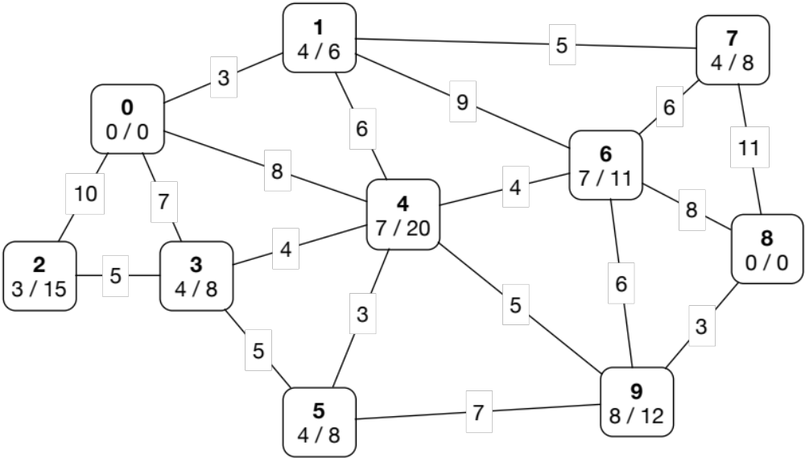
Figure 2: A sample graph for tour planning scenario.

Q2 [10 marks] Way Finding Assistance

The way finding function should identify the shortest path from an origin node to a destination node. For this function, we don’t need to consider node value or node touring time; instead, we are only interested in the travel time between nodes.
Requirements:
- Write a method called find_way that takes 3 arguments, and returns an array of node sequence that corresponds to the shortest path.
find_way(adj_matrix, origin, dest)
- adj_matrix: a 2D array storing edge travel times between any two nodes in the graph; adj_matrix[i][j] is the travel time from node i to node j. If it’s not possible to directly travel from i to j, adj_matrix[i][j] will be set to nil to represent ∞.
- origin: the origin node ID.
- dest: the destination node ID.

This method should return an array of nodes representing the sequence of nodes that corresponds to the shortest path connecting the origin and destination (both origin and destination should also be in the returned array). In the event that there is no path connecting the origin and destination, your method should return nil.
- Your method should complete within 5 minutes on the Submission Server.

For example, for the graph in Figure 2, the adj_matrix is defined as:
 | 0 | 1 | 2 | 3 | 4 | 5 | 6 | 7 | 8 | 9
0 | ∞ | 3 | 10 | 7 | 8 | ∞ | ∞ | ∞ | ∞ | ∞
1 | 3 | ∞ | ∞ | ∞ | 6 | ∞ | 9 | 5 | ∞ | ∞
2 | 10 | ∞ | ∞ | 5 | ∞ | ∞ | ∞ | ∞ | ∞ | ∞
3 | 7 | ∞ | ∞ | ∞ | 4 | 5 | ∞ | ∞ | ∞ | ∞
4 | 8 | 6 | ∞ | 4 | ∞ | 3 | 4 | ∞ | ∞ | 5
5 | ∞ | ∞ | ∞ | 5 | 3 | ∞ | ∞ | ∞ | ∞ | 7
6 | ∞ | 9 | ∞ | ∞ | 4 | ∞ | ∞ | 6 | 8 | 6
7 | ∞ | 5 | ∞ | ∞ | ∞ | ∞ | 6 | ∞ | 11 | ∞
8 | ∞ | ∞ | ∞ | ∞ | ∞ | ∞ | 8 | 11 | ∞ | 3
9 | ∞ | ∞ | ∞ | ∞ | 5 | 7 | 6 | ∞ | 3 | ∞

Suppose the origin is node 0 and the destination is node 8, the returned shortest path sequence should be: [0, 4, 9, 8], with path length equaling 16 time units.
You are given the following files for this exercise:
File name | Description | Comments
p2q2.rb | Contains the find_way method that you will write. | You need to modify and submit this file. This is the only file that you may submit. Do not modify the file name or the method signature in the file.
p2q2_main.rb | Loads p2q2.rb and calls the find_way method. | Do not submit this file; use it to check if your find_way method in p2q2.rb works.
p2_utility.rb | Contains accessory methods. | Do not submit this file.  You may use get_distance that can be found here.
data/g_<?>.csv | CSV files that represent graphs that can be read by p2q2_main.rb. | The first line in this CSV file indicates the number of nodes in this graph. (Node IDs will always start from 0, and continue sequentially. e.g. a 10-node graph will have nodes with IDs 0, 1, 2… 9.) Each subsequent line contains information in this format:  nodeX, nodeY, dist betw nodes in time units  The distance between 2 nodes is always the same regardless of whether one is travelling from the first node to the second, or vice versa.  This CSV file will be read and constructed into an adj_matrix array and passed into the find_way method.
  File name | Node num | Comments
  g_10.csv | 10 | Graph shown in fig 2.
  g_100a.csv | 100 | Low density
  g_100b.csv | 100 | Medium density
  g_100c.csv | 100 | High density
  g_500a.csv | 500 | Low density
  g_500b.csv | 500 | Medium density
  g_500c.csv | 500 | High density

Your task:
- Edit p2q2.rb provided to meet the requirements. Ensure that your solution works correctly with g_10.csv before submitting it to the Submission Server.

Assessment:
- You will be graded for correctness and time taken. There will always be only one correct shortest distance, but there could be more than one correct path that results in that shortest distance.
- The Quality Score on the Submission Server for a correct answer is always 1.0.

Q3 [20 marks] Tour Planning

The tour planning function should recommend a sequence of attraction nodes to visit, with the objective of maximizing collected node values, yet subject to the time limitation. More specifically, given a pair of origin and destination nodes and the limit on the total time a user can spend, this function should return an array of nodes that represents the recommended tour. Note that all nodes in the array, except for the origin and the destination nodes, will be visited and incur touring times to receive node values. Also note that a node should appear at most once in the returned array. The only exception is the situation whereby the origin node is the same as the destination node, in which case that origin/destination node is visited twice to form a circular path.

Requirements:
- Write a method called plan_tour that takes 6 parameters and returns an array of nodes representing the recommended tour.
plan_tour(adj_matrix, node_values, node_times, origin, dest, time_limit)
- adj_matrix: the same as defined in Q2.
- node_values: an array storing values for all nodes. (e.g. [7, 1, 0, 2] means that the values for nodes 0, 1, 2 and 3 are 7, 1, 0 and 2 respectively.)
- node_times: an array storing touring time for all nodes. (e.g. [3, 6, 4, 4] means that the touring times for nodes 0, 1, 2 and 3 are 3, 6, 4 and 4 time units respectively.)
- origin: the origin node ID.
- dest: the destination node ID.
- time_limit: the maximum amount of time the user can spend before reaching destination. The total time taken on your recommended tour includes both the (i) touring time at each node in your path, NOT counting the touring time at the origin and destination nodes, and (ii) travelling time between nodes in your tour. This total time should not exceed time_limit.
The function should return an array of node IDs representing the sequence of nodes that corresponds to the recommended tour (both origin and destination should also be in the returned array). Like Q2, in the event where there is no path connecting the origin and destination, or no path that satisfies the time_limit (meaning that it’s impossible to recommend a tour), your method should return nil.
- Your method should complete within 10 minutes on the Submission Server.

You are given the following files for this exercise:
File name | Description | Comments
p2q3.rb | Contains the plan_tour method that you will write. | You need to modify and submit this file. This is the only file that you may submit. Do not modify the file name or the method signature in the file.
p2q3_main.rb | Loads p2q3.rb and calls the plan_tour method. | Do not submit this file; use it to check if your plan_tour method in p2q3.rb works.
p2_utility.rb | Contains accessory methods. | Do not submit this file.  You may use get_time and get_value that can be found here.
data/g_<?>.csv  data/vt_<?>.csv | CSV files that represent graphs that can be read by p2q3_main.rb. | vt_10.csv contains data about the values and touring times at each node for a 10-node graph, and can be used with any 10-node graph (e.g. g_10.csv). vt_100.csv can be used with any 100-node graph etc.  Format of vt_<?>.csv:  node ID, value, touring time  These CSV files will be read and constructed into adj_matrix, node_values and node_times, and passed into your plan_tour method.  Other CSVs are provided that represent larger graphs.

Your task:
- Edit p2q3.rb and submit this file at the submission server.
- Submit a PDF file containing up to ONE page at the eLearn Dropbox describing your algorithm clearly and explaining why your algorithm is a good one.

Assessment:
- You will be graded for correctness and time taken. Your solution is considered “correct” if the time_limit for your recommended tour is not exceeded, and your tour begins and ends at the given origin and destination nodes. [5 marks]
- The Quality Score on the Submission Server is the total value of all the nodes in your recommended tour. [10 marks]
- Explanation on how you design your algorithm (PDF file). [5 marks]

~ End

